***DOWNLOAD Cucumber for Eclipse***

***Cucumber*** *functionality is abstracted out in jars and following Cucumber jars/modules are required to run a Cucumber test with Java in Eclipse.*

1. *cucumber-core*
2. *cucumber-java*
3. *cucumber-junit*
4. *cucumber-jvm-deps*
5. *cucumber-reporting*
6. *gherkin*
7. *junit*
8. *mockito-all*
9. *cobertura*

*There are many options to download Cucumber jars for Eclipse.*

***OPTION 1 : Download Cucumber Jars from Maven Repository***

1. *Go to* [*https://search.maven.org*](https://search.maven.org)

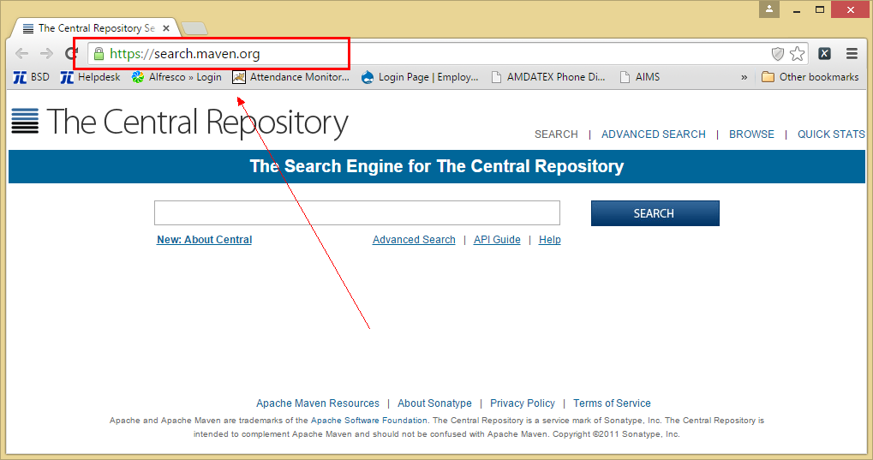

1. *Search for* ***cucumber-core*** *in the Central Maven Repository. It will return the Cucumber Core jars. Click on the* ***jar****.*

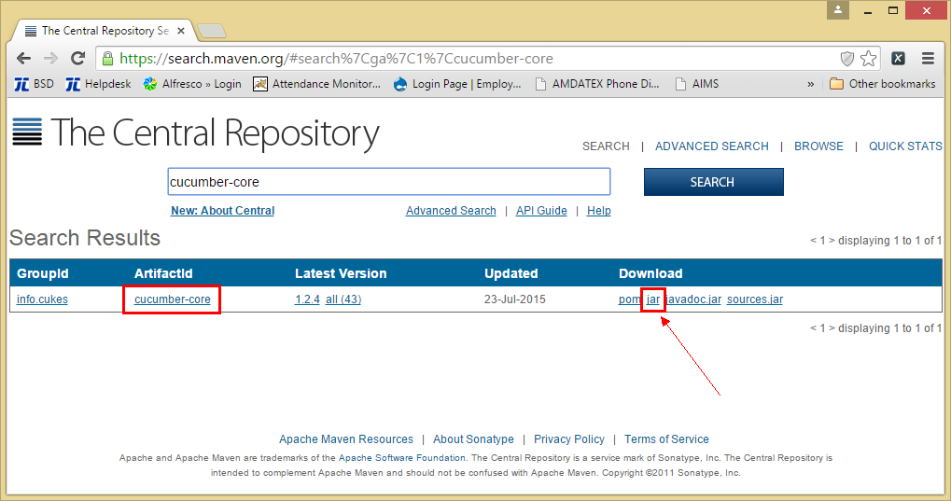

1. *It will display a pop up and ask you to save the* ***cucumber core jar*** *file.*

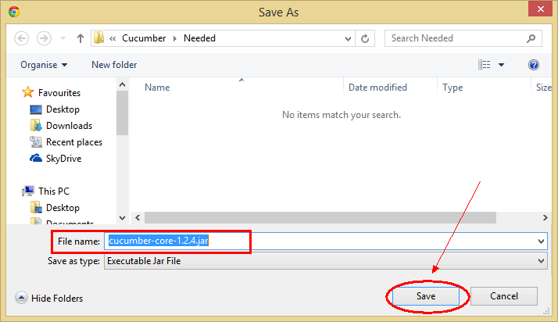

1. *Just like this, one by one search for* ***every other jar file mentioned above*** *and downloads these to your drive.*

***Note*** *that core, java and junit files all need to be the same file version e.g. 1.2.4*

***OPTION 2 : Download Cucumber Jars from oss.sonatype.org***

1. *Go to* [*https://oss.sonatype.org/content/repositories/releases/info/cukes/*](https://oss.sonatype.org/content/repositories/releases/info/cukes/) *. Here also all the cucumber jars are available. Start with cucumber-core.*

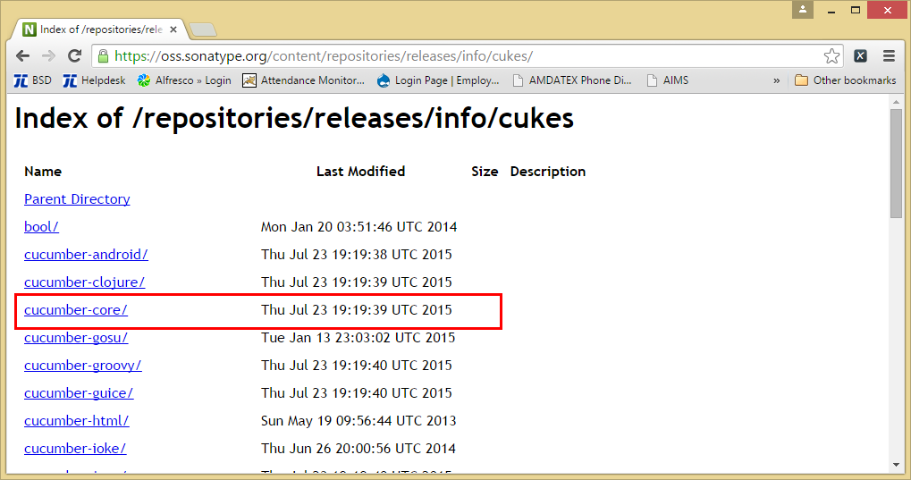

1. *Click on the latest version at the bottom of the page, which is* ***version 1.2.4*** *as of now by July’15.*

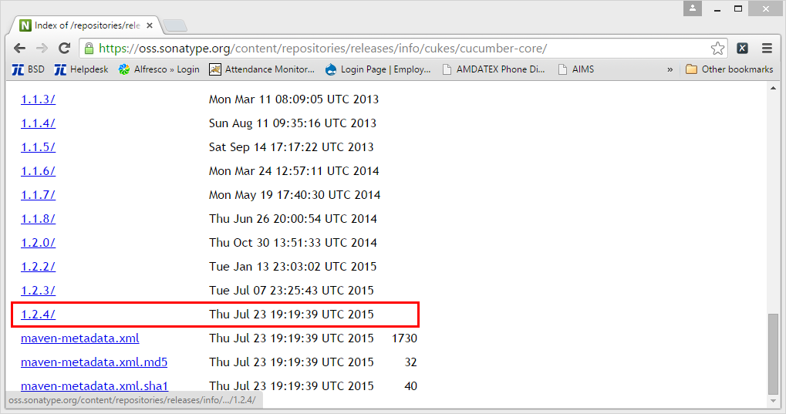

1. *Once clicked on the version, it will display the all types of jar available to download. Click on* ***cucumber-core-1.2.0.jar*** *.*

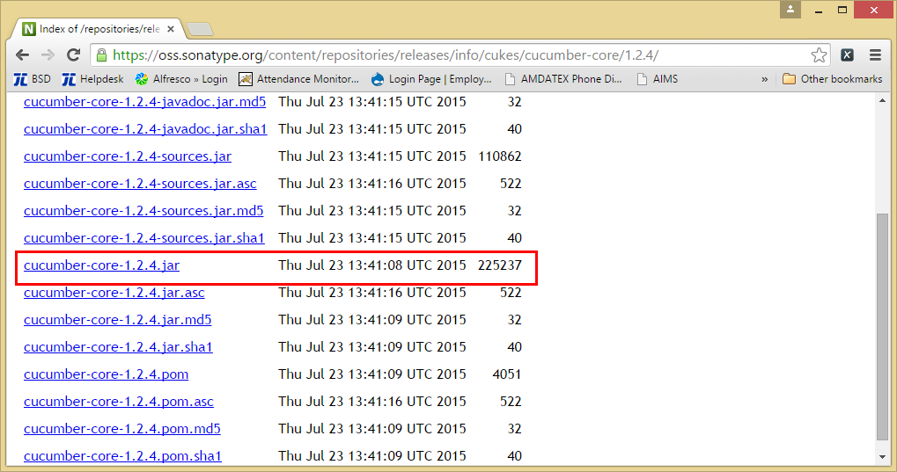

1. *Just like this, downloads all of these to your drive and every other jar is available on the same page.*

***Note*** *that core, java and junit files all need to be the same file version e.g. 1.2.4*